Exploratory Data Analysis for Covid-19

Data Science Capstone Project
Data Acquisition and Preprocessing Report
10/26/2020

Team Members:
Avani Jain
Toby Sheung
Michael Wesner

Identifying Data
Data Sources:
Below is the COVID-19 dataset that is collected for every country from December 2019 to the date in which a user downloads the dataset. It contains every date from those ranges and details the total cases, new cases, total deaths, new deaths for each country. This dataset is quite extensive and contains more than 49,000 rows and 41 columns detailing numbers of COVID-19. We chose this dataset due to its extensive information and how the numbers are stated for each day.
- https://covid.ourworldindata.org/

Below is our second dataset that we used to detail the sex and age groups of COVID-19 related deaths in the United States. Since the first dataset did not have information about age groups and sex, this dataset will be combined into our project to explain how COVID-19 affects age groups and/or sex differently. This will help to further explore the trends of COVID-19 deaths.
- https://data.cdc.gov/NCHS/Provisional-COVID-19-Death-Counts-by-Sex-Age-and-S/9bhg-hcku

Acquisition Process:
There are currently two datasets we are using for this project. Both datasets are ready for download in either a CSV or XLSX data file. Both are downloadable from their respective websites. The datasets are acquired from public sources. We will not integrate the two datasets together because age groups and sex cannot be integrated into the dataset about countries’ COVID-19 cases and deaths. Each dataset will be analyzed separately to understand the trends of COVID-19.

Data-Processing:
[Examine the data you have acquired and understand the data properties. Is there any pre-processing you need to do before you can start analyzing the data? For example, missing data, sparsity, noise, veracity, ambiguity, interoperability, etc. Describe each data issue in a sub-section and explain how you clean up the data.]
The first dataset requires an extensive amount of data processing due to its missing values. There are some countries missing dates in the dataset.
-We could either delete the countries that do not have all the dates. Only use countries that have at least N/A for dates that they do not have information. It will be hard to figure out for each country if they are missing a date row to add that specific one since there is over 212 countries.
-As long as the dates are in the row with N/A, we could use front filling to fill in numbers that were a day previous so that the numbers make more sense. If a country has a date from December 2019 with 0 covid-19 cases and the next available date is in March 2020, the front fill could possibly skew the information.
Since there are 41 columns in the dataset, there are probably some variables that are not needed for this EDA project such as variables with number smoothing.
-Remove the variables that are irrelevant to this project

Appendix
[Provide the code or pseudo code, data definition, sample data, and any other information in the appendix here.]
- Covid-19 Dataset with Countries: https://covid.ourworldindata.org/

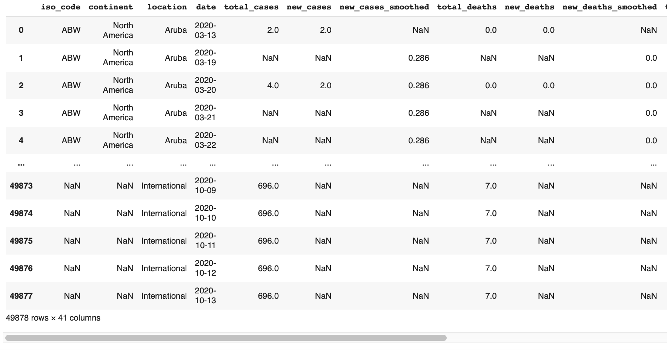

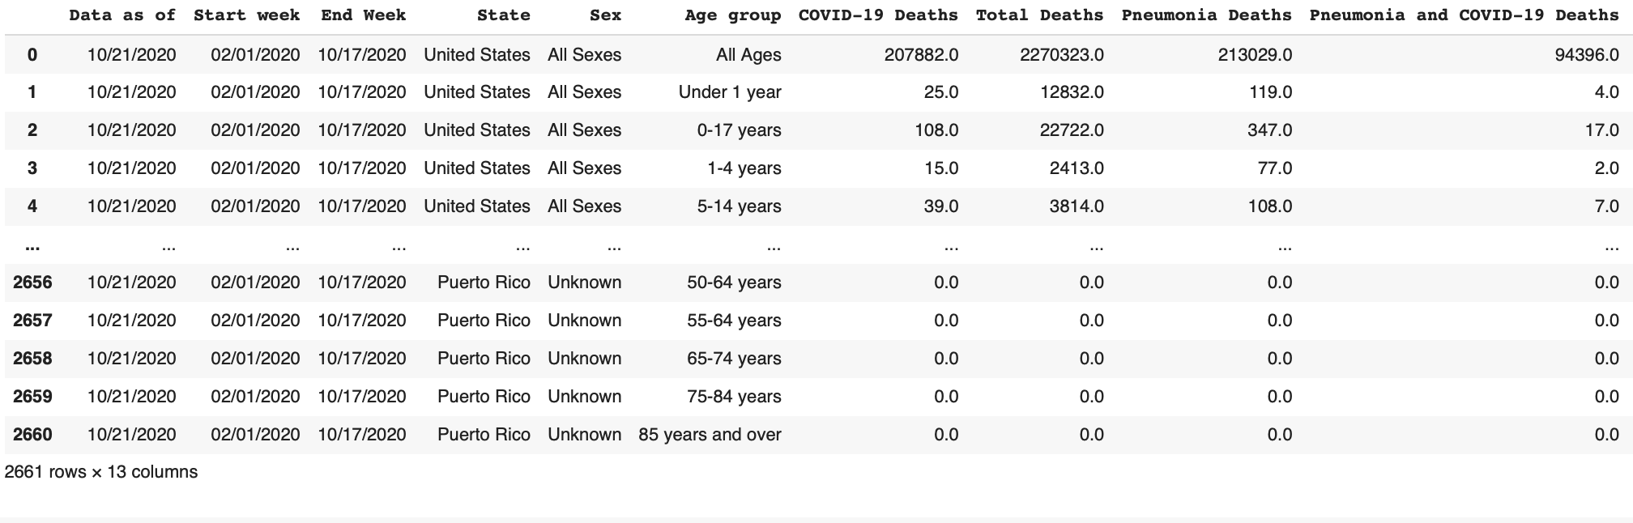
- Covid-19 Dataset with Gender and Sex: https://data.cdc.gov/NCHS/Provisional-COVID-19-Death-Counts-by-Sex-Age-and-S/9bhg-hcku

Table of Contributions
The table below identifies contributors to various sections of this document.

 | Section | Writing | Editing
1 | Data Sources | Toby | Michael
2 | Data Pre-Processing | Toby, Michael | Michael
3 | Appendix | Toby

Grading
The grade is given on the basis of quality, clarity, presentation, completeness, and writing of each section in the report. This is the grade of the group. Individual grades will be assigned at the end of the term when peer reviews are collected.

